CAMPAIGN
- THE KEY VISUAL
“Every label has a story’
The phrase shows that every piece of clothing has its own past and memories. By upcycling them, we give those clothes a brand-new second life. This phrase explains how old garments are transformed into cool, unique fashion for the festival.

2. CAMPAIGN ASSETS
PHASE 1: TEASER (2 WEEKS BEFORE FESTIVAL)
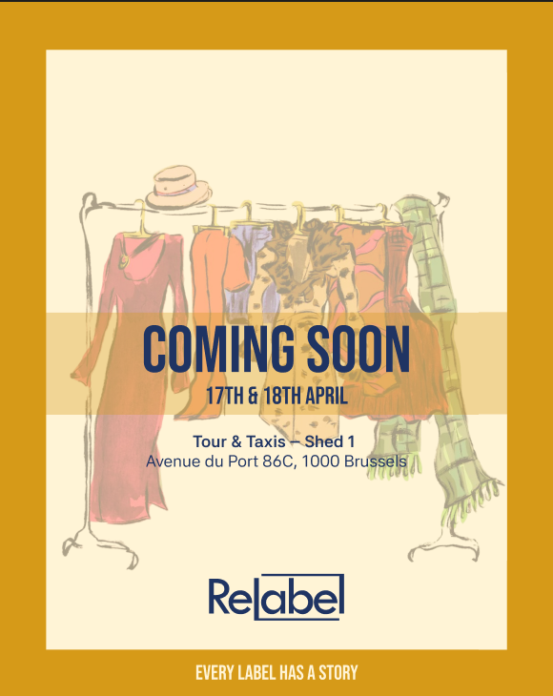 | Story coming soon  Creates curiosity around the upcoming (Re)label festival by giving people a first glimpse of the campaign. The clothing illustrations introduce the fashion theme, while the Coming Soon message builds anticipation and encourages people to look forward to the announcement. The date and location give the audience a small preview of what's coming.

PHASE 2: LAUNCH (DONATION WEEKEND - 27TH & 28TH MARCH)
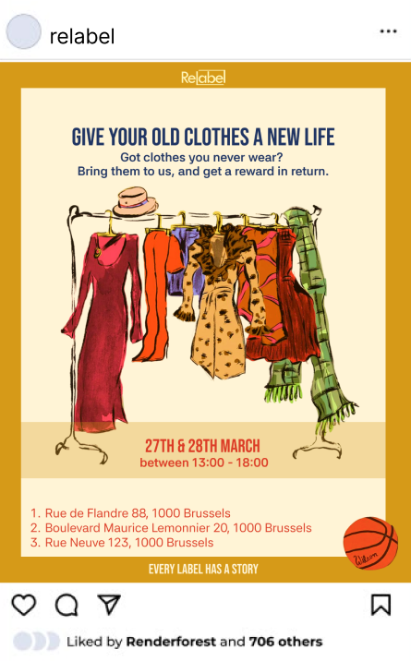  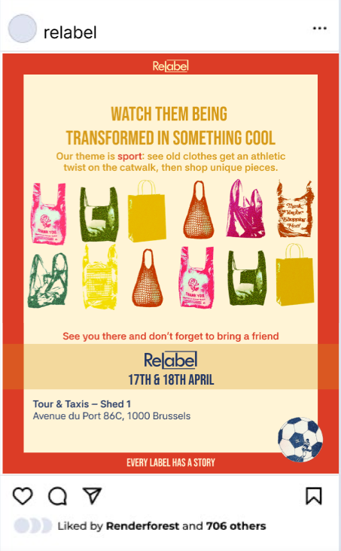 | CHANNEL 2: INSTAGRAM CAROUSEL  Targeted social media feed post for persona Sarah.  Objective: People can drop their clothes off at 3 locations written on the post. The voucher gives motivation AND can be used on festival (so they have to come if they want to use their voucher)

PHASE 3: during (FESTIVAL WEEKEND - 17TH & 18TH APRIL)
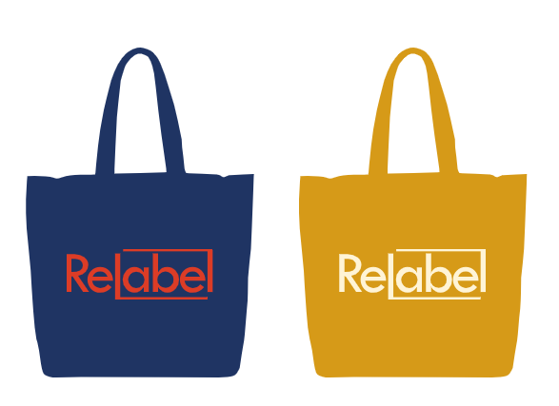 | totebag  The tote bag promotes the festival and its identity. It can be used by visitors to carry their belongings or donated clothes, while spreading the (Re)label branding.

PHASE 4: during (festival WEEKEND - 17TH & 18TH MARCH)
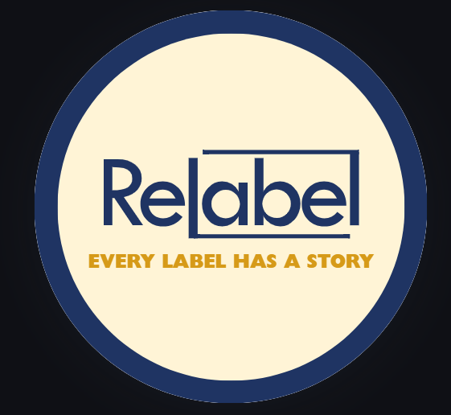 | pins  The pin features the line Every label has a story. Visitors can wear it as a small souvenir of the festival and help spread the campaign's message.

